**Project Management Tool**

1. Create a project Net Banking Application

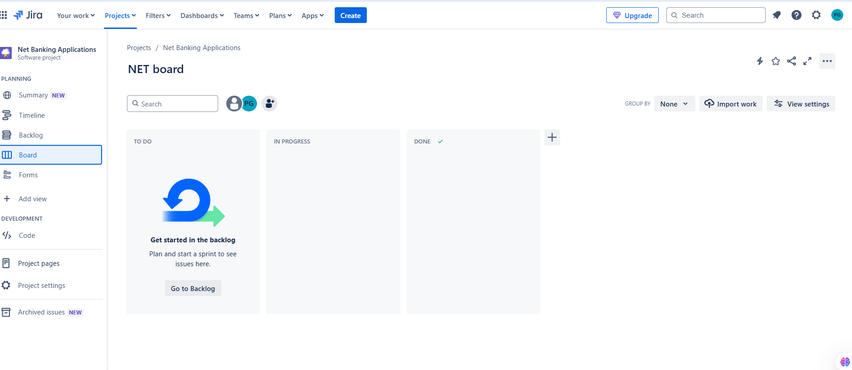

2)Create 5 Epic

* Login Module
* Payment module
* Transaction module
* Security module
* Customer Relationship Module

3)Create a User Story for each Epic in Product Backlog

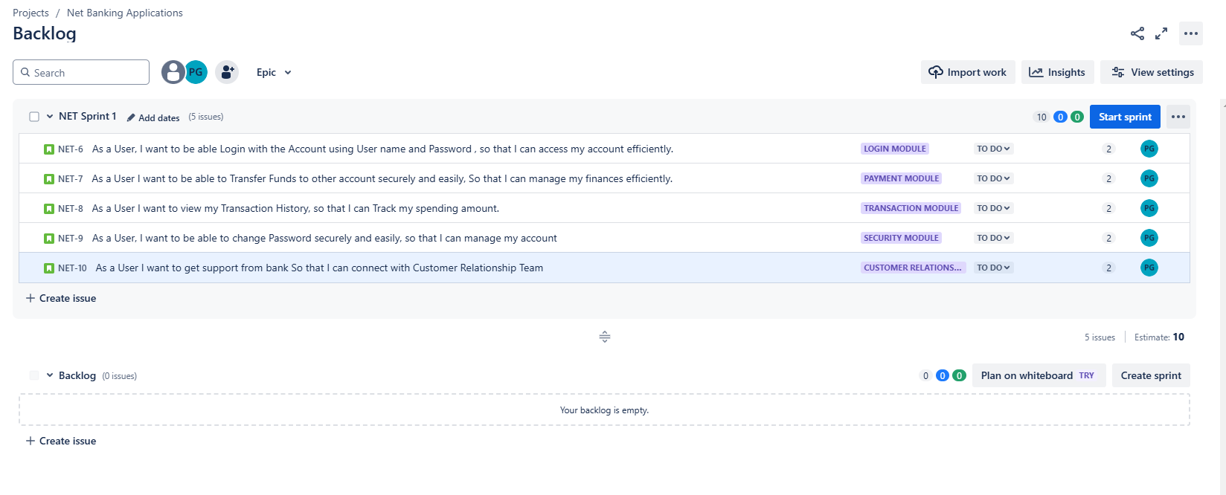4) Moving a product backlog to sprint backlog

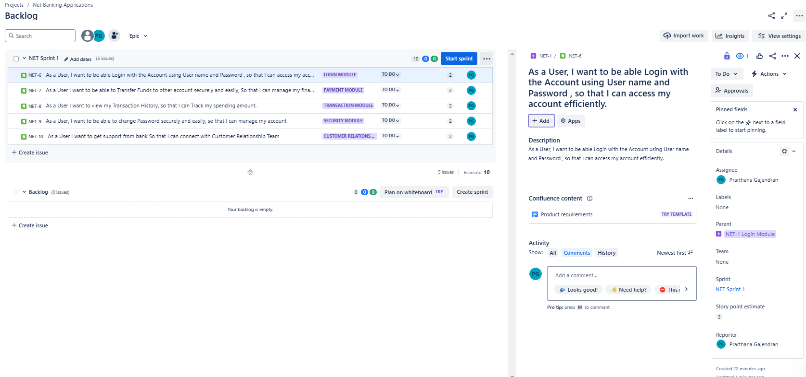

5)Sprint 1 created for Login Module

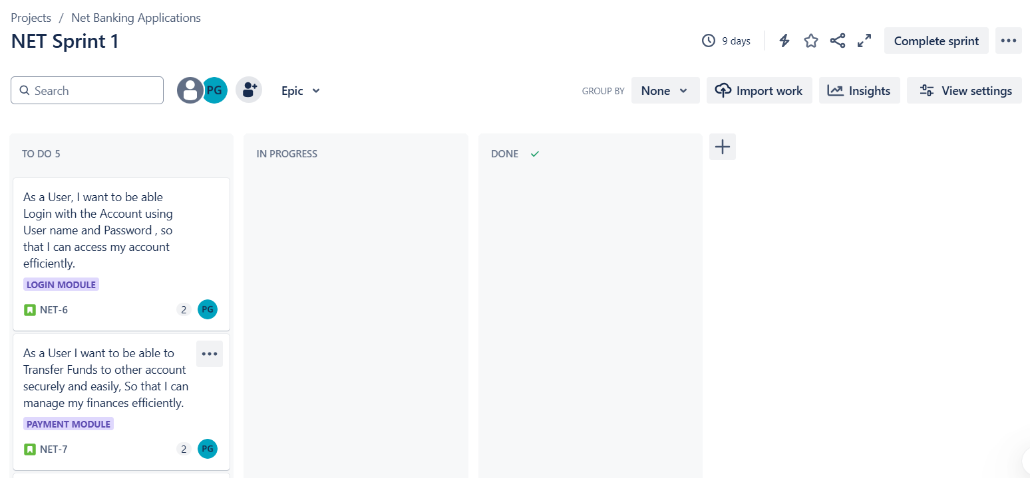

6)Sprint 1 moved from To Do to In Progress and To done

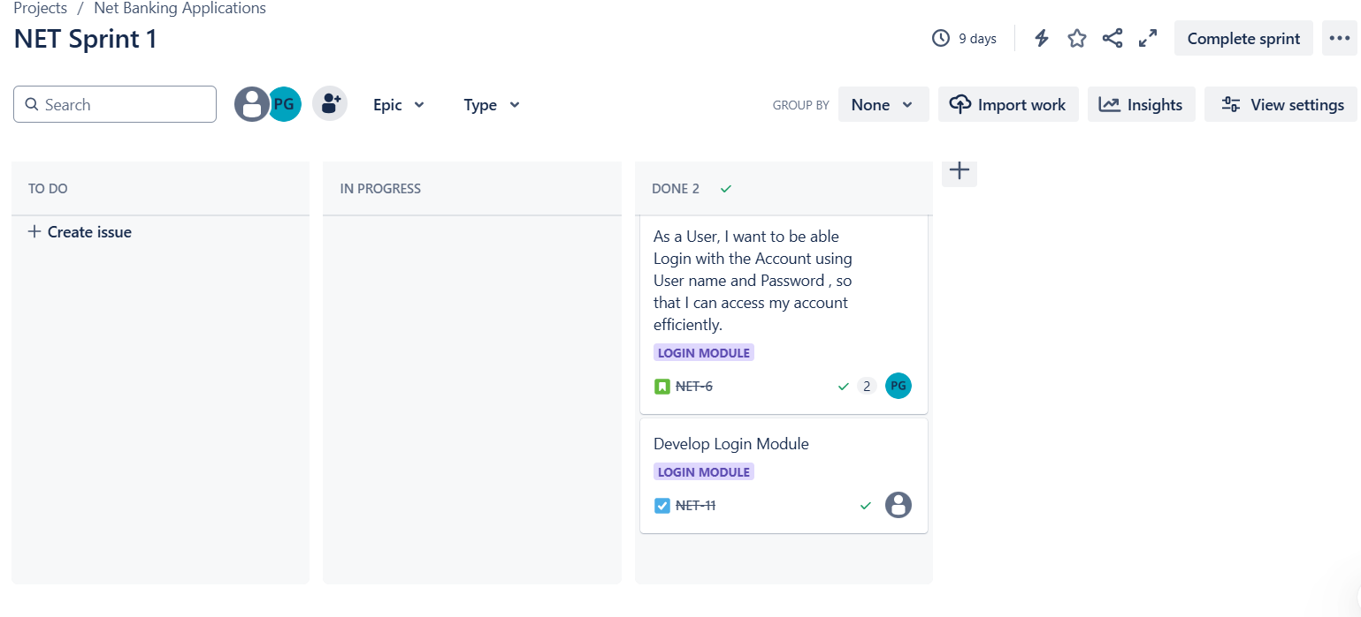

7)Sprint 1 completed

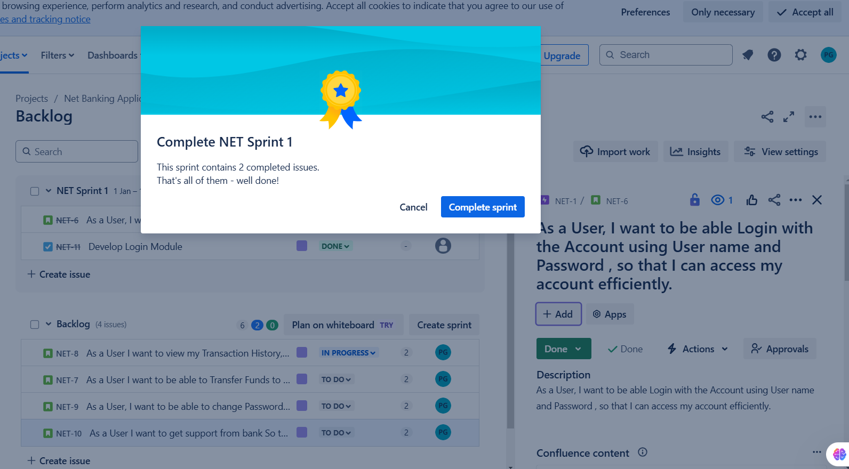

8)Sprint 2 (Transaction Module) and 3 (Security Module) created

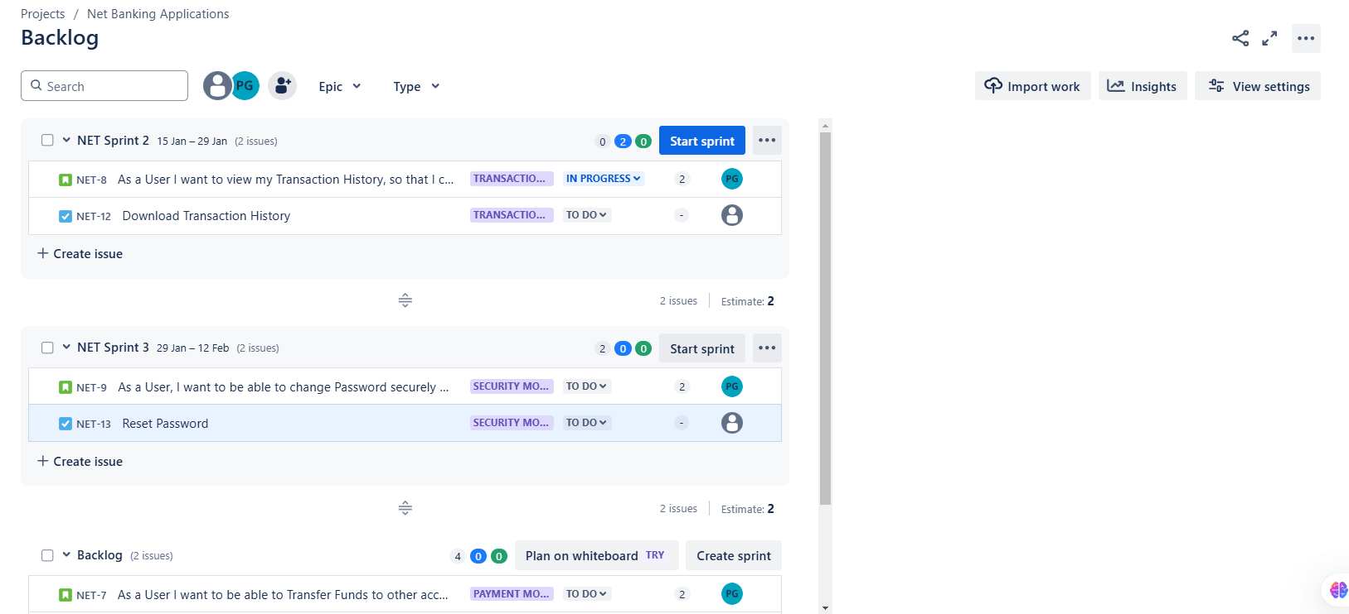

9)Sprint 2 started and moved to In Progress

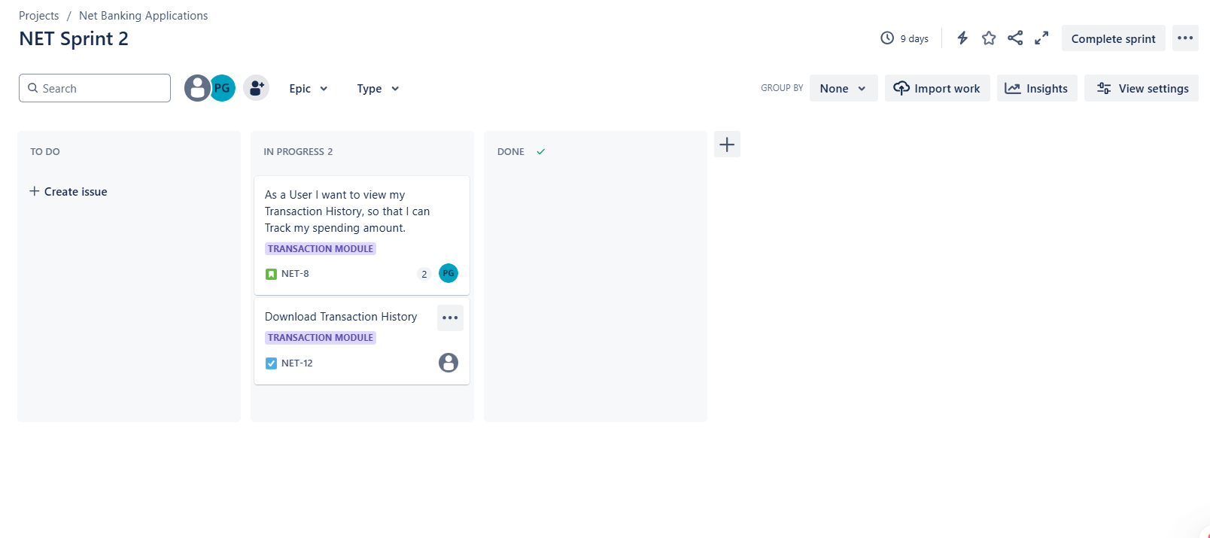10)Sprint 2 User story moved from In Progress to Done

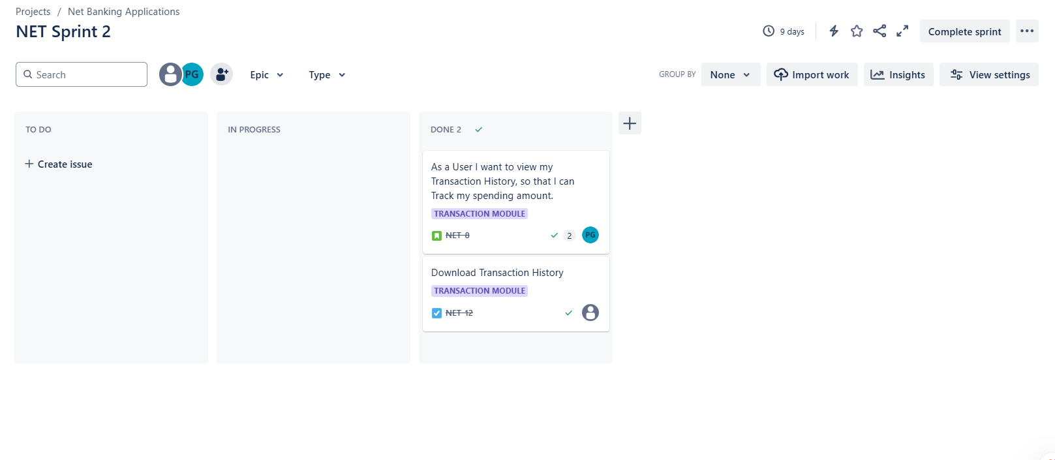

11)Adding issues in Module

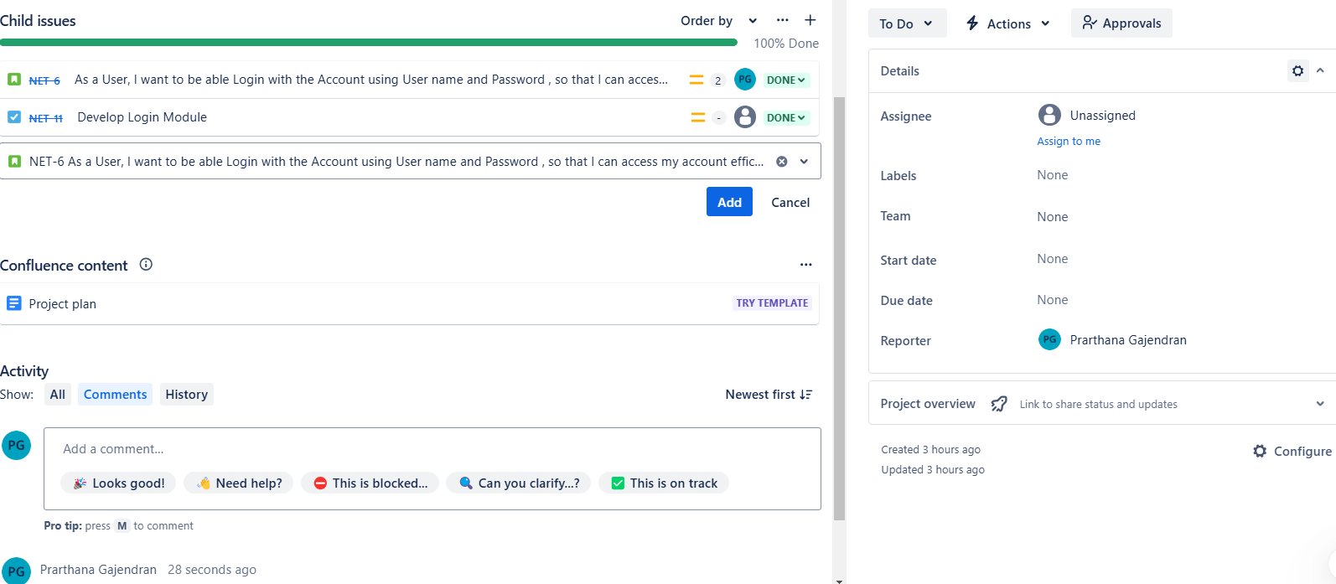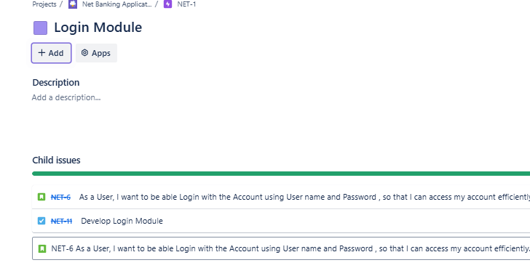

12)Sprint 2 Completed

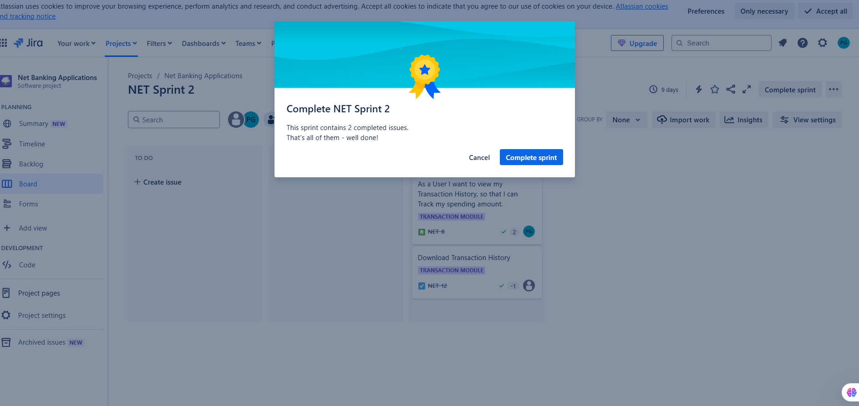

13)Sprint 3 Created and moved User story to To Do

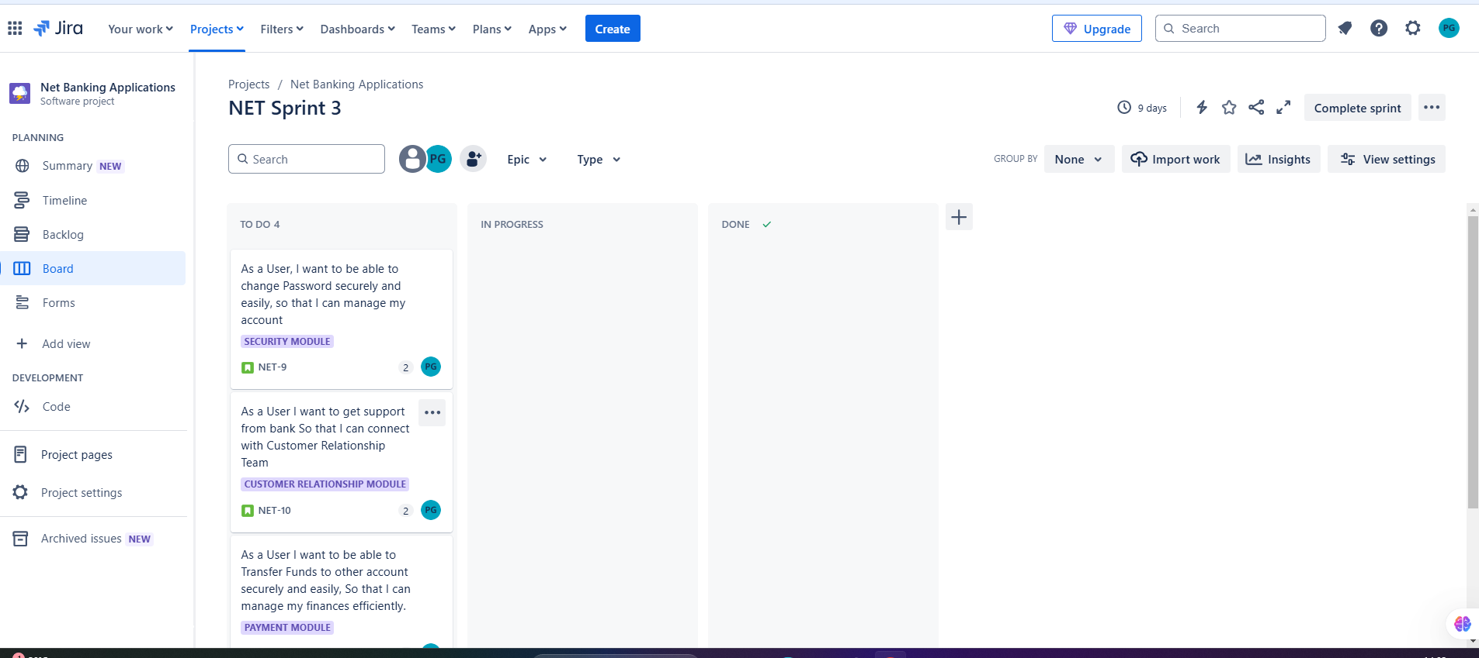

14)Sprint 3 User story moved from To Do to In Progress

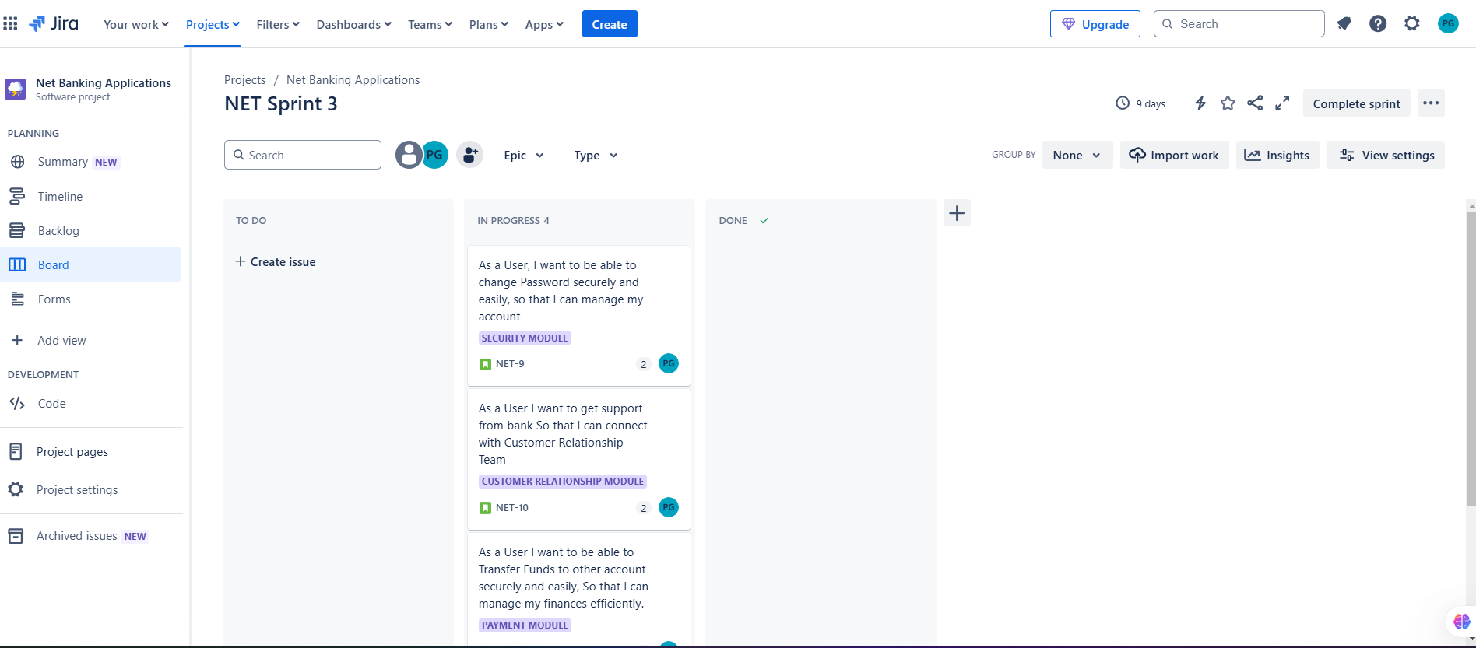

15)Sprint 3 User story moved from In Progress to Done

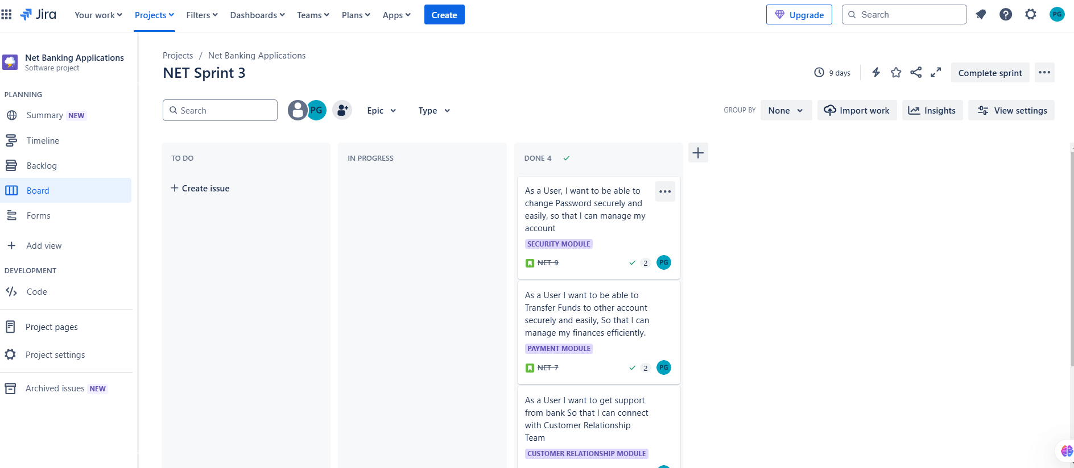

16)Sprint 3 completed

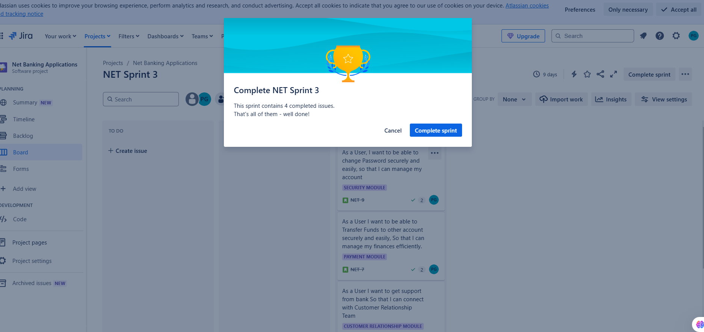

17)Issue created in completed Sprint **(Sprint review)**

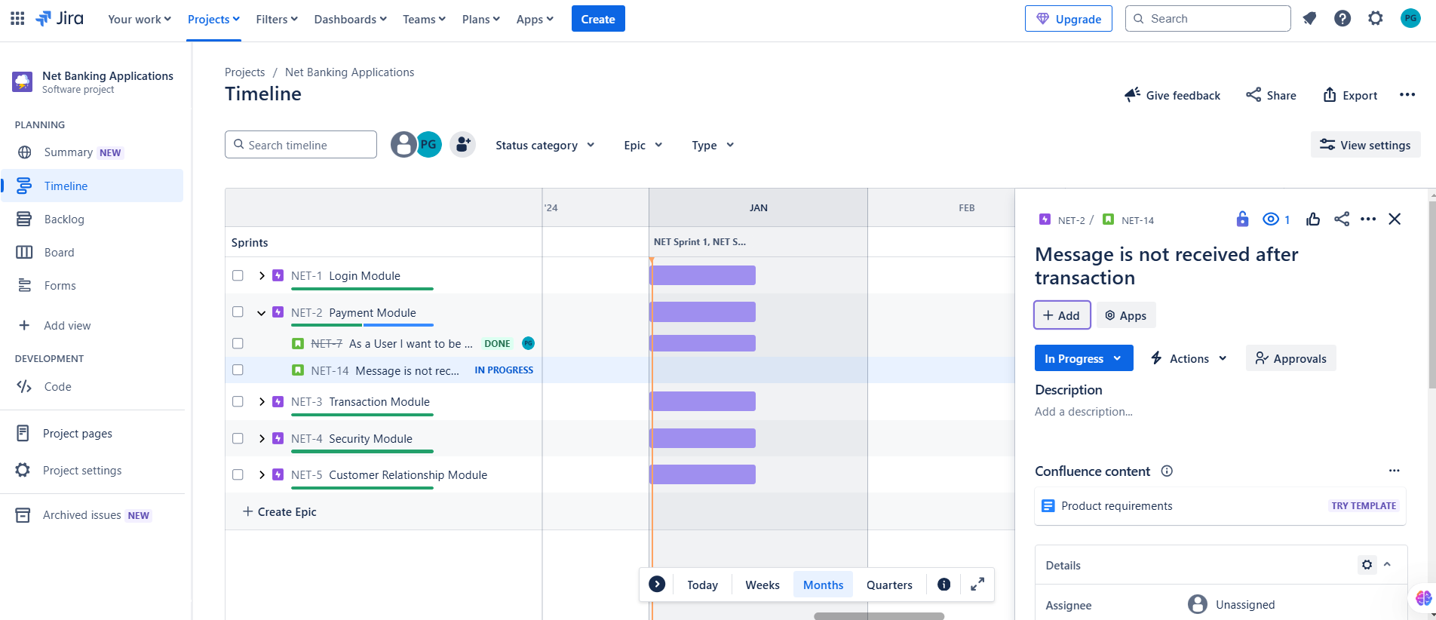

18)Sprint again started for Issue found in Payment Module

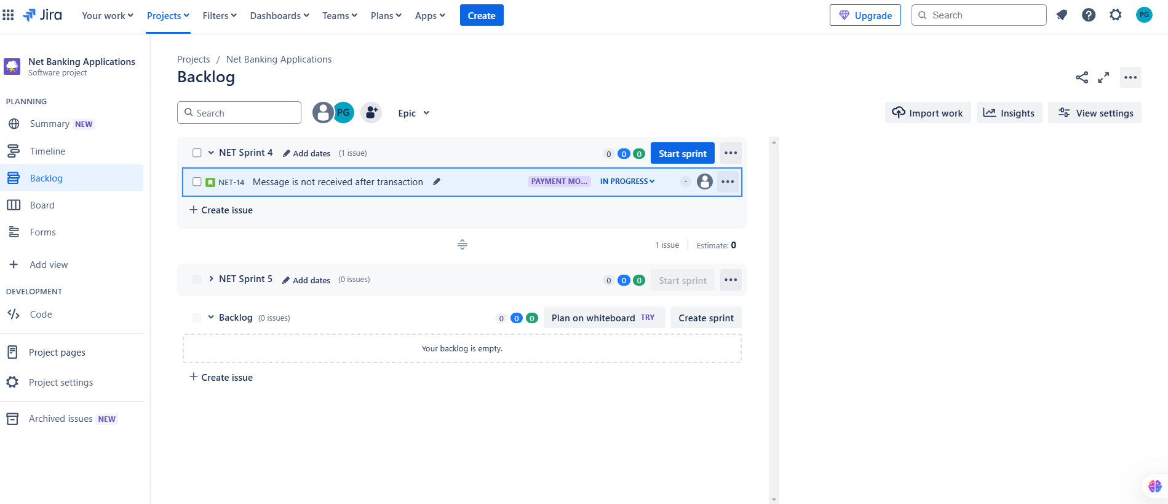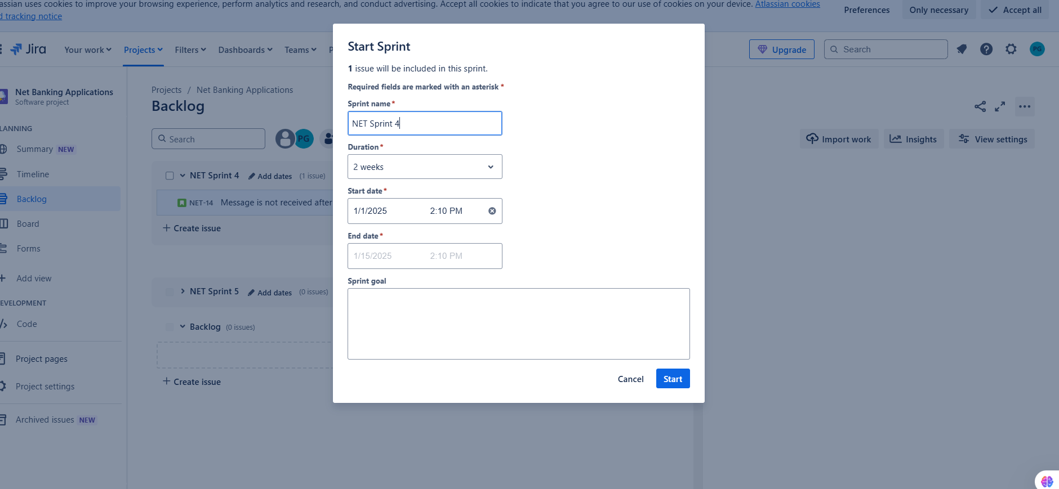Sprint Created

19)Sprint 4 In Progress

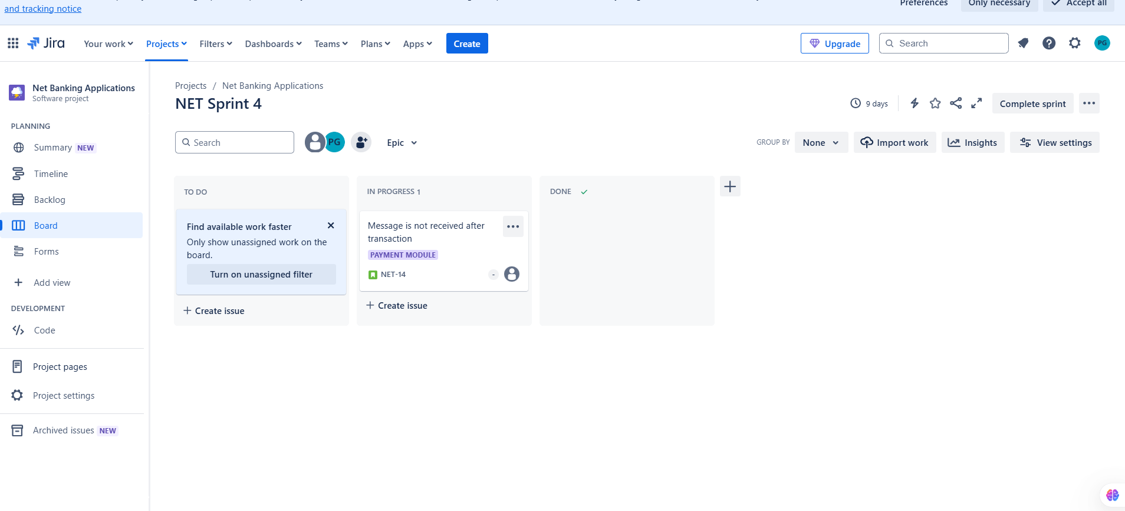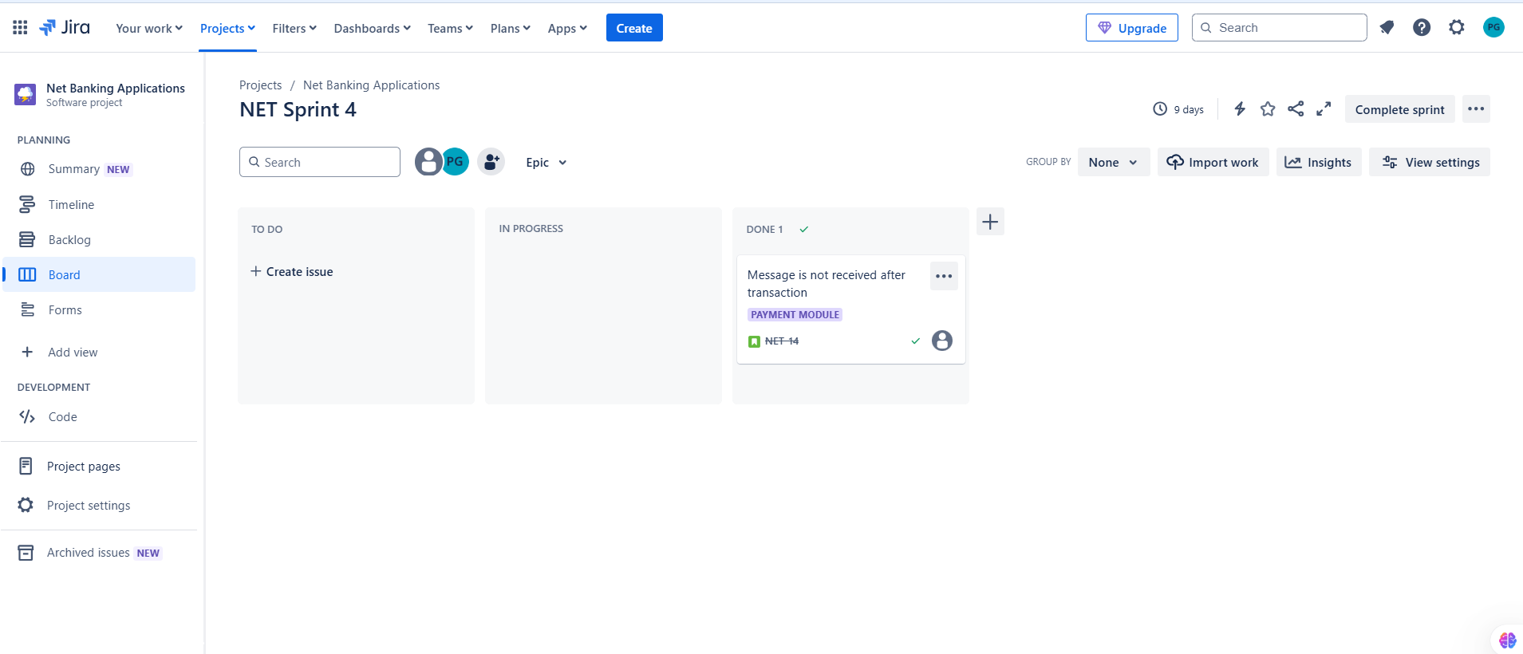

20)Sprint 4 completed

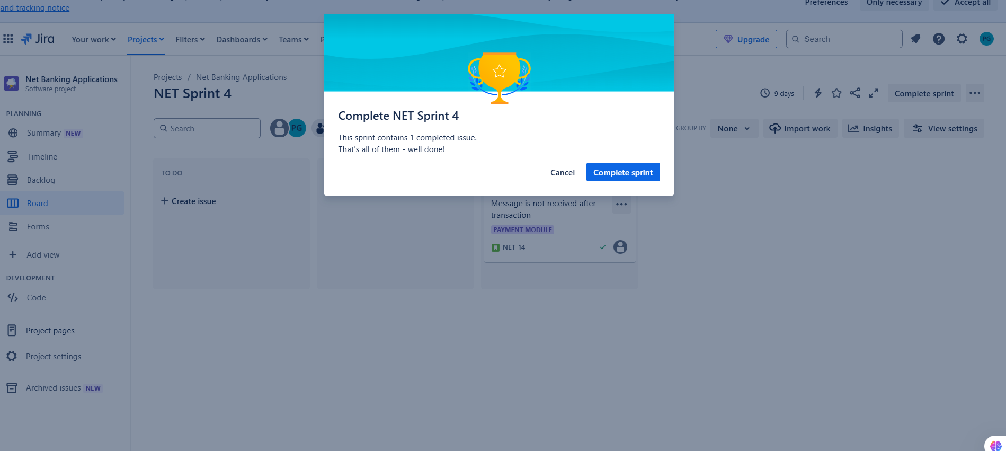

21)Timeline after resolved the Issue

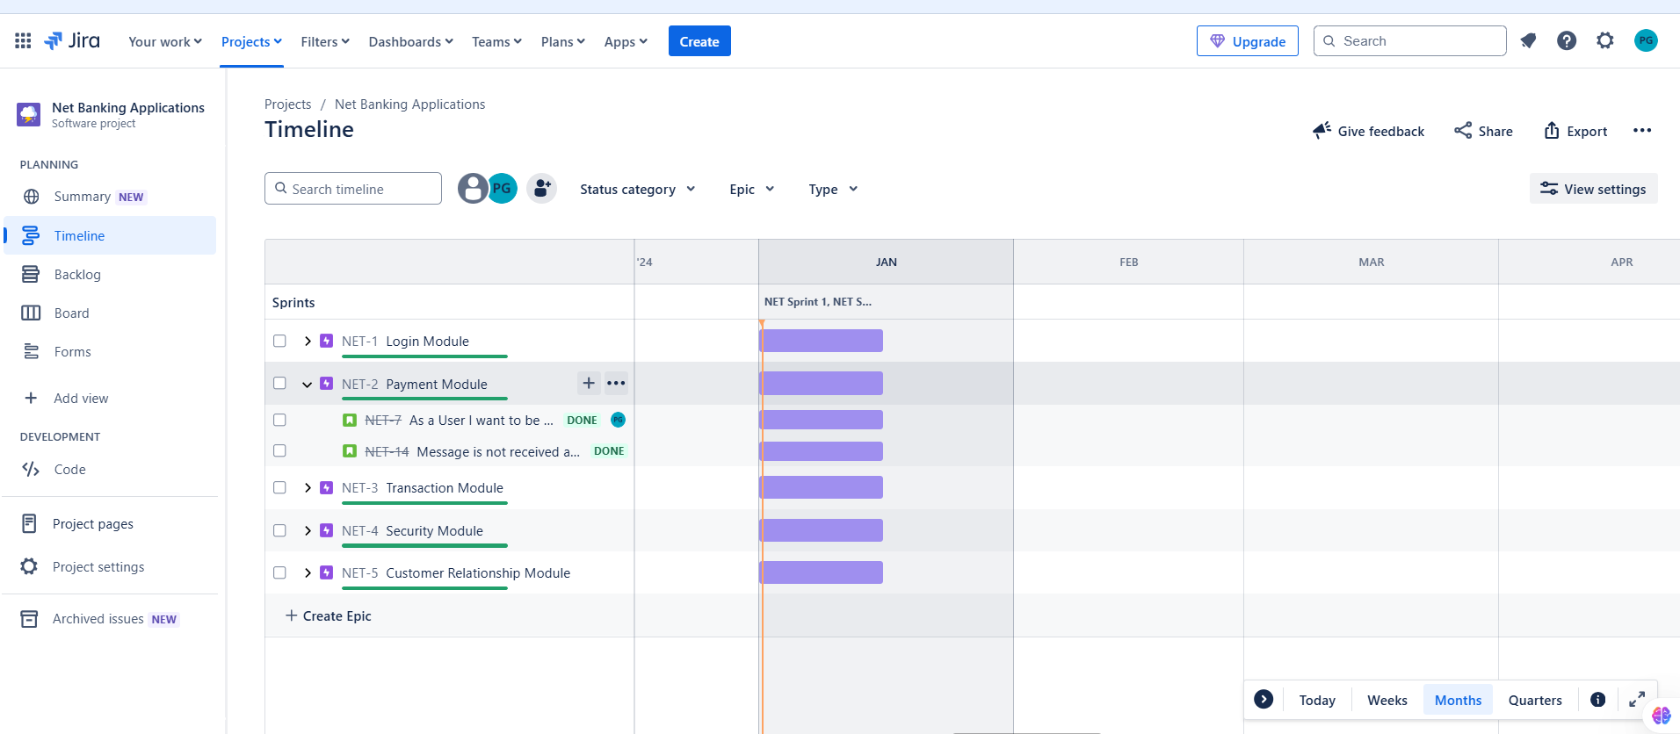22)Velocity Report of Net Banking Application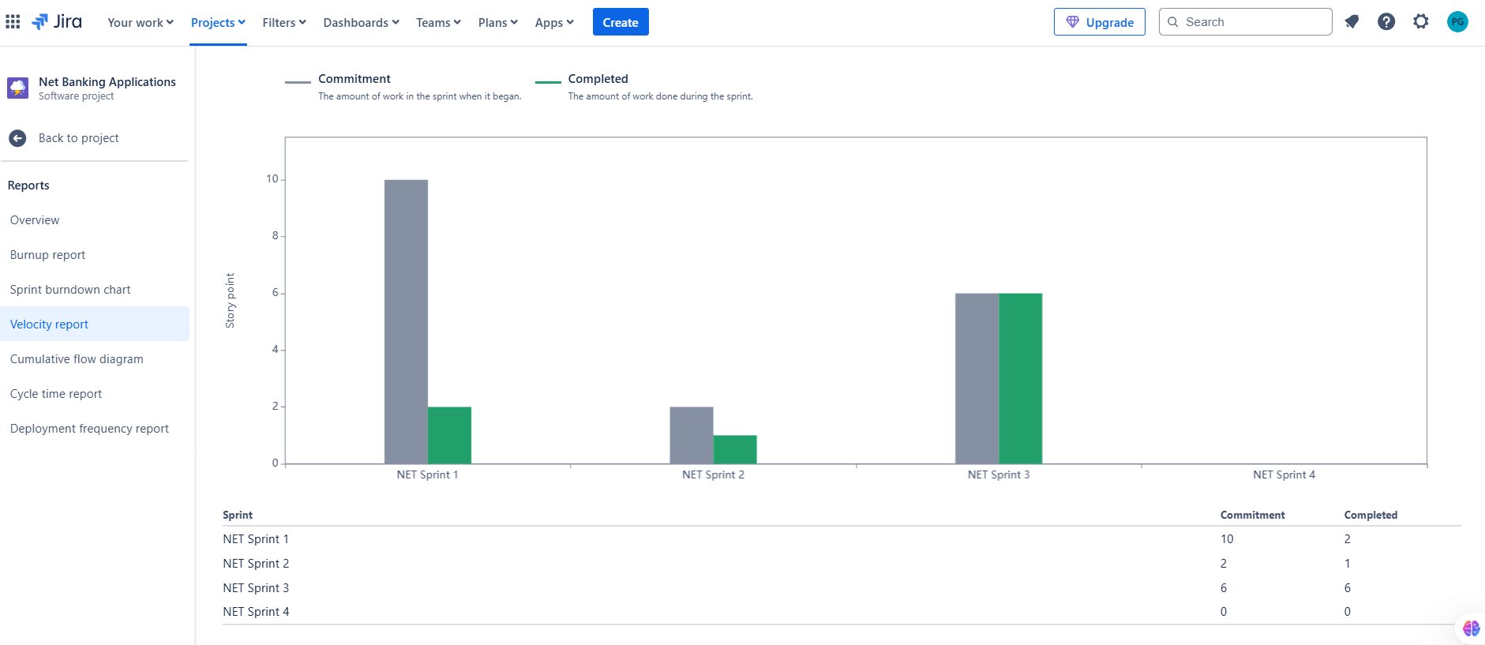

**Sprint Retrospective:**

Issue created after a completion of sprint 2 is again resolved in sprint 4.

Need to concentrate on Security Module.

**Release Planning -Net Banking Application Version 1.0**

**8th january 2024**

**Login Module**

1)Users can register in a Net Banking Application.

2)Users are able to Login the Application with valid User Name and Password.

3)User can able to Reset the Password

4)User can able to change Profile Information such as Mobile Number,Email etc

**Payment module**

1)Users can be able to Transfer Money from their Account to another account. 2)User can able to select the Mode of Transactions

**15th january 2024**

**Transaction module**

1)User can be able to see the transactions made in the Account

2)User can able to download the transaction History

3)User can able to pay Electricity bills,Phone bills

**Security module**

1)User can able to get a message after every Transactions

2)User can abl get the OTP for Authentication

**Customer Relationship Module**

1)If User has any queries they are able to contact the Bank Anytime.

2)If User made a wrong transaction, they can contact the Bank to Stop the Transaction.

**Roles involved in Scrum**

Product Owner-Defines requirements and priorities

Business Analyst-Ensure clear documentation and requirements

Master-Facilitates the process and remove roadblock

Tech Architect Development team and Testing Team-Ensure to Develop and Testing the requirements

Operation Team-Handles deployment and Maintenance